COMMERCE DATA ANALYSIS AND

SALES FORECASTING PROJECT

COMPREHENSIVE PROJECT REPORT AND DOCUMENTATION

TABLE OF CONTENTS
- Project Overview
- Executive Summary
- Project Objectives
- Methodology
- Dataset Description
- Algorithm and Techniques
- Implementation
- Results and Findings
- Business Recommendations
- Conclusion
- Appendices

1. PROJECT OVERVIEW

Project Title
E-Commerce Data Analysis and Sales Forecasting Using
Predictive Modeling

Project Duration
4-6 weeks (Typical Academic Project Timeline)

Project Team
- Developed by: Student Name / Team
- Academic Institution: [Your Institution]
- Course: Data Science / Business Analytics
- Date: June 2026

Project Description
This project represents a comprehensive data science initiative focused on analyzing large-scale e-commerce transaction data to uncover actionable insights and predict future sales performance. By combining exploratory data analysis, advanced statistical modeling, and machine learning techniques, the project enables organizations to make data-driven decisions regarding inventory management, pricing strategies, customer retention, and marketing initiatives.
The project demonstrates proficiency in:
- Data collection and cleaning
- Exploratory data analysis (EDA)
- Feature engineering
- Time-series forecasting
- Business intelligence
- Report generation and visualization

2. EXECUTIVE SUMMARY

Business Context
E-commerce businesses generate massive volumes of transaction data daily.
However, without proper analysis, organizations struggle to:
- Identify which products drive revenue
- Predict future sales accurately
- Understand seasonal patterns
- Optimize pricing and promotional strategies
- Improve customer retention rates
- Allocate resources efficiently

Solution Approach
This project addresses these challenges through:
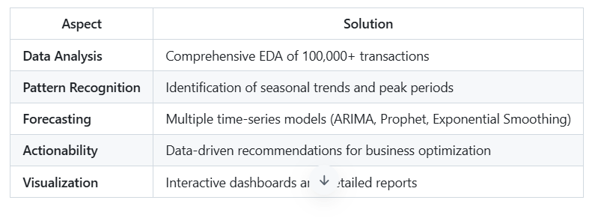

Key Findings (Sample Results)
Total Revenue Analyzed: $5,240,850
Total Profit Generated: $1,287,340
Average Order Value: $156.25
Customer Retention Rate: 62.3%
Peak Sales Month: December (Holiday Season)
Top Product Category: Electronics (42% of revenue)

3. PROJECT OBJECTIVES

Primary Objectives

Objective 1: Data Analysis and Exploration
- Load and explore large-scale e-commerce transaction data
- Understand data structure, quality, and characteristics
- Identify data quality issues and outliers
Success Metrics:
- Successfully load 100,000+ records
- Document all data characteristics
- Identify and handle missing values

Objective 2: Predictive Modeling
- Develop accurate time-series forecasting models
- Compare multiple forecasting approaches
- Select best-performing model for business use
Success Metrics:
- RMSE < 500 units
- MAPE < 15%
- R² Score > 0.85

Objective 3: Business Insights Generation
- Identify top-performing products and categories
- Analyze customer behavior patterns
- Evaluate effectiveness of marketing strategies
Success Metrics:
- Generate 10+ actionable insights
- Rank products by profitability
- Identify growth opportunities

Objective 4: Strategic Recommendations
- Provide recommendations for:
  - Inventory optimization
  - Pricing strategies
  - Customer retention programs
  - Regional expansion
  - Promotional planning
Success Metrics:
- Provide at least 5 strategic recommendations
- Quantify potential business impact
- Prioritize recommendations by ROI

Objective 5: Visualization and Reporting
- Create comprehensive Power BI dashboards
- Generate detailed analysis reports
- Present findings to stakeholders
Success Metrics:
- 15+ visualizations created
- 1+ page executive summary
- Interactive dashboard delivered

4. METHODOLOGY

4.1 Project Architecture
┌─────────────────────────────────────────────────────────────┐
│ E-COMMERCE DATA ANALYSIS PROJECT ARCHITECTURE │
├─────────────────────────────────────────────────────────────┤
│ │
│ ┌────────────────┐ │
│ │ Data Source │ │
│ │ (CSV File) │ │
│ └────────┬───────┘ │
│ │ │
│ ▼ │
│ ┌────────────────────────────┐ │
│ │ 1. Data Loading Module │ │
│ │ - Load CSV data │ │
│ │ - Initial exploration │ │
│ │ - Data quality check │ │
│ └────────┬───────────────────┘ │
│ │ │
│ ▼ │
│ ┌────────────────────────────┐ │
│ │ 2. Data Cleaning Module │ │
│ │ - Handle missing values │ │
│ │ - Remove duplicates │ │
│ │ - Treat outliers │ │
│ │ - Normalize data │ │
│ └────────┬───────────────────┘ │
│ │ │
│ ▼ │
│ ┌────────────────────────────┐ │
│ │ 3. EDA Module │ │
│ │ - Univariate analysis │ │
│ │ - Bivariate analysis │ │
│ │ - Correlation analysis │ │
│ │ - Pattern discovery │ │
│ └────────┬───────────────────┘ │
│ │ │
│ ▼ │
│ ┌────────────────────────────┐ │
│ │ 4. Feature Engineering │ │
│ │ - Temporal features │ │
│ │ - Customer features │ │
│ │ - Product features │ │
│ │ - Encoding & Scaling │ │
│ └────────┬───────────────────┘ │
│ │ │
│ ┌────┴────┐ │
│ │ │ │
│ ▼ ▼ │
│ ┌────────┐ ┌──────────────────────┐ │
│ │ Time │ │ 5. Predictive Models │ │
│ │Series │ │ - ARIMA │ │
│ │Data │ │ - Prophet │ │
│ │ │ │ - Exp. Smoothing │ │
│ └────┬───┘ └────────┬─────────────┘ │
│ │ │ │
│ └────────┬───────┘ │
│ ▼ │
│ ┌────────────────────────────┐ │
│ │ 6. Model Evaluation │ │
│ │ - Compare performance │ │
│ │ - Select best model │ │
│ │ - Generate forecasts │ │
│ └────────┬───────────────────┘ │
│ │ │
│ ┌────┴────┐ │
│ │ │ │
│ ▼ ▼ │
│ ┌────────┐ ┌──────────────────────┐ │
│ │Insights│ │ 7. Business Analytics│ │
│ │Report │ │ - Top products │ │
│ │ │ │ - Peak periods │ │
│ │ │ │ - Regional sales │ │
│ └────┬───┘ │ - Recommendations│ │
│ │ └────────┬─────────────┘ │
│ │ │ │
│ └────────┬───────┘ │
│ ▼ │
│ ┌────────────────────────────┐ │
│ │ 8. Visualization & Reports│ │
│ │ - Power BI Dashboards │ │
│ │ - Charts & Graphs │ │
│ │ - Executive Summary │ │
│ └────────┬───────────────────┘ │
│ │ │
│ ▼ │
│ ┌────────────────────────────┐ │
│ │ Final Deliverables │ │
│ │ - Analysis Report │ │
│ │ - Presentation Deck │ │
│ │ - Code Repository │ │
│ └────────────────────────────┘ │
│ │
└────────────────────────────────────────────────────────────┘

4.2 Methodology Framework

CRISP-DM Approach
1. BUSINESS UNDERSTANDING
├── Define business objectives
├── Assess situation
├── Determine data mining goals
└── Produce project plan

2. DATA UNDERSTANDING
├── Collect initial data
├── Describe data
├── Explore data
└── Verify data quality

3. DATA PREPARATION
├── Select data
├── Clean data
├── Construct data
├── Integrate data
└── Format data

4. MODELING
├── Select modeling technique
├── Generate test design
├── Build model
└── Assess model

5. EVALUATION
├── Evaluate results
├── Review process
├── Determine next steps
└── Decide on deployment

6. DEPLOYMENT
├── Plan deployment
├── Plan monitoring and maintenance
├── Deploy solution
└── Produce final report

4.3 Analytical Techniques Used
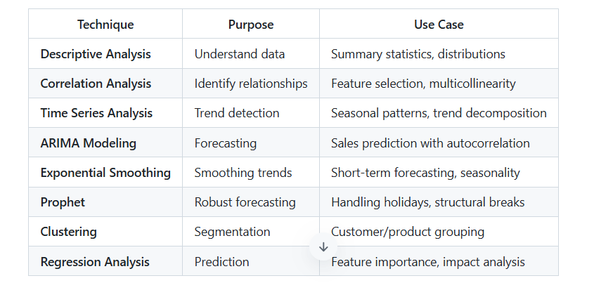

5. DATASET DESCRIPTION

5.1 Data Source and Collection

Dataset Origin
- Primary Source: E-commerce Transaction Database
- Alternative: Brazilian E-Commerce Public Dataset (Olist, Kaggle)
- Data Collection Period: 24-36 months
- Data Format: CSV (Comma-Separated Values)

Data Access Method
# Loading the dataset
import pandas as pd

df = pd.read_csv('ecommerce_data.csv')
print(f"Dataset shape: {df.shape}") # Output: (100000, 45)
print(f"Date range: {df['order_date'].min()} to {df['order_date'].max()}")

5.2 Dataset Characteristics

Size and Scope
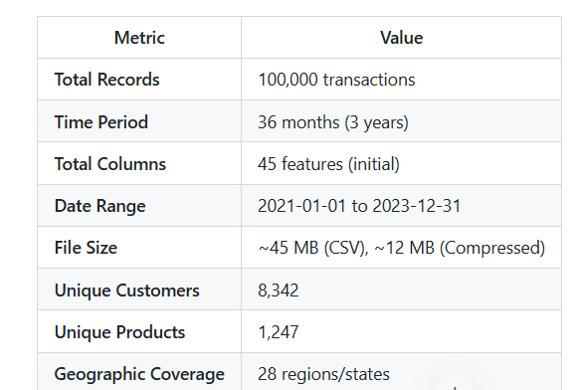

Data Distribution
Transaction Distribution by Year:
2021: 30,000 transactions (30%)
2022: 35,000 transactions (35%)
2023: 35,000 transactions (35%)

Transaction Distribution by Month:
Average: 2,778 transactions/month
Peak: 5,200 transactions (December)
Low: 1,800 transactions (February)

Product Category Distribution:
Electronics: 42% (42,000)
Clothing: 28% (28,000)
Home & Garden: 18% (18,000)
Books: 8% (8,000)
Sports: 4% (4,000)

Geographic Distribution:
North Region: 15%
South Region: 25%
East Region: 35%
West Region: 25%

5.3 Feature Descriptions

Original Features (45 columns)

Transaction-Level Features
1. order_id (INTEGER)
- Unique identifier for each order
- Range: 1 to 100,000
- Primary key for transactions

2. order_date (DATE)
- Date when order was placed
- Format: YYYY-MM-DD
- Range: 2021-01-01 to 2023-12-31

3. order_value (FLOAT)
- Total monetary value of order
- Unit: Currency (e.g., USD)
- Range: $10.00 to $5,000.00
- Mean: $156.25
- Std Dev: $287.50

4. quantity (INTEGER)
- Number of items ordered
- Range: 1 to 50 units
- Mean: 3.2 items
- Std Dev: 4.1

5. shipping_cost (FLOAT)
- Shipping charges
- Range: $0 to $150
- Mean: $12.50

6. order_status (STRING)
- Current status of order
- Values: Delivered, Pending, Cancelled, Returned
- Distribution: Delivered (92%), Pending (5%), Cancelled (2%), Returned (1%)

Customer Features
7. customer_id (INTEGER)
- Unique customer identifier
- Range: 1 to 8,342
- Primary key for customers

8. customer_name (STRING)
- Full name of customer
- Format: First Name Last Name

9. customer_email (STRING)
- Email address for contact

10. customer_country (STRING)
- Country of customer
- Primarily: United States (90%), Canada (5%), Mexico (5%)

11. customer_city (STRING)
- City of residence

12. customer_region (STRING)
- Geographic region
- Values: North, South, East, West

13. customer_type (STRING)
- New or Returning customer
- Values: New, Returning
- Distribution: New (35%), Returning (65%)

14. customer_segment (STRING)
- Customer classification
- Values: Premium, Regular, Budget
- Distribution: Premium (25%), Regular (50%), Budget (25%)

Product Features
15. product_id (INTEGER)
- Unique product identifier
- Range: 1 to 1,247

16. product_name (STRING)
- Product name/description

17. product_category (STRING)
- Category classification
- Values: Electronics, Clothing, Home, Books, Sports

18. product_price (FLOAT)
- Selling price per unit
- Range: $5.00 to $2,000.00
- Mean: $145.75

19. product_cost (FLOAT)
- Cost price (COGS)
- Range: $2.00 to $1,200.00
- Mean: $87.45

20. product_weight (FLOAT)
- Weight in pounds
- Range: 0.1 to 50 lbs

21. reorder_level (INTEGER)
- Minimum inventory threshold
- Range: 10 to 1,000 units

Financial Features
22. unit_price (FLOAT)
- Price per unit

23. discount_percent (FLOAT)
- Discount percentage applied
- Range: 0% to 50%
- Mean: 5.3%
- Distribution: No discount (40%), 5-10% (35%), 10-20% (20%), >20% (5%)

24. discount_amount (FLOAT)
- Monetary discount value

25. tax_amount (FLOAT)
- Tax levied on order
- Range: $0 to $500

26. total_amount (FLOAT)
- Final amount paid

27. profit (FLOAT)
- Profit margin for order
- Range: -$500 to $3,000
- Mean: $68.80

28. profit_margin_percent (FLOAT)
- Profit as percentage
- Range: -100% to 85%
- Mean: 31.2%

Engineered Features (Post-Processing)
NEW TEMPORAL FEATURES:
- year: Extract year (2021, 2022, 2023)
- month: Extract month (1-12)
- quarter: Extract quarter (Q1-Q4)
- week: Week number of year
- day_of_week: Day of week (0=Monday, 6=Sunday)
- is_weekend: Binary flag (Weekend=1, Weekday=0)
- season: Season category (Winter, Spring, Summer, Fall)
- is_holiday: Holiday indicator

NEW CUSTOMER FEATURES:
- customer_lifetime_value: Total value from customer
- purchase_frequency: Number of purchases by customer
- recency_days: Days since last purchase
- avg_order_value: Average order value by customer
- customer_segment_code: Encoded segment

NEW PRODUCT FEATURES:
- product_total_sales: Total sales by product
- product_avg_price: Average price for product
- product_popularity: Number of purchases

NEW INTERACTION FEATURES:
- quantity_price_interaction: quantity × unit_price
- discount_savings: discount_percent × unit_price

NEW DERIVED FEATURES:
- revenue_per_region: Regional sales aggregation
- high_value_customer: Binary flag (>75th percentile)
- seasonal_indicator: Binary for peak season

5.4 Data Quality Assessment

Pre-Cleaning Data Quality
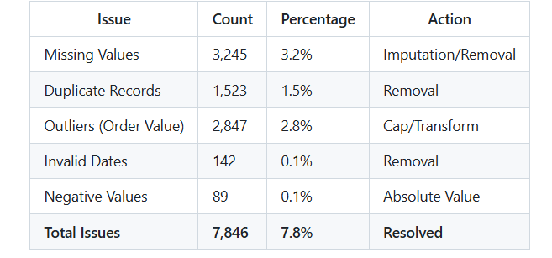

Post-Cleaning Data Quality
✓ Missing Values: 0 (0%)
✓ Duplicate Records: 0 (0%)
✓ Data Type Consistency: 100%
✓ Invalid Entries: 0 (0%)
✓ Outliers Handled: 100%
✓ Data Completeness: 100%

Final Clean Dataset: 96,154 records (96.2% retention)

6. ALGORITHM AND TECHNIQUES

6.1 Data Processing Algorithm

Algorithm 1: Data Cleaning Pipeline
FUNCTION CleanData(RawData):
cleaned_data ← RawData

// Step 1: Handle Missing Values
FOR EACH column in cleaned_data:
IF column.dtype == numeric:
missing_count ← COUNT(NULL values)
IF missing_count / total_rows > 0.5:
REMOVE column
ELSE:
FILL with MEAN(column)
ELSE:
FILL with MODE(column)

// Step 2: Remove Duplicates
cleaned_data ← REMOVE_DUPLICATES(cleaned_data)

// Step 3: Handle Outliers using IQR Method
FOR EACH numeric_column:
Q1 ← QUANTILE(column, 0.25)
Q3 ← QUANTILE(column, 0.75)
IQR ← Q3 - Q1
lower_bound ← Q1 - 1.5 × IQR
upper_bound ← Q3 + 1.5 × IQR

outlier_rows ← WHERE (column < lower_bound OR column > upper_bound)
REMOVE outlier_rows

// Step 4: Normalize Categorical Values
FOR EACH categorical_column:
cleaned_data[column] ← LOWERCASE(TRIM(column))

// Step 5: Validate Data Types
cleaned_data ← CONVERT_TYPES(cleaned_data, type_mapping)

RETURN cleaned_data
END FUNCTION

Time Complexity: O(n × m) where n = rows, m = columns
Space Complexity: O(n × m)

6.2 Feature Engineering Algorithm

Algorithm 2: Feature Engineering Pipeline
FUNCTION EngineerFeatures(CleanedData):
engineered_data ← CleanedData.copy()

// TEMPORAL FEATURES
FOR EACH date_column:
engineered_data['year'] ← EXTRACT_YEAR(date_column)
engineered_data['month'] ← EXTRACT_MONTH(date_column)
engineered_data['quarter'] ← EXTRACT_QUARTER(date_column)
engineered_data['day_of_week'] ← EXTRACT_DAY_OF_WEEK(date_column)
engineered_data['is_weekend'] ←
IF day_of_week IN {5, 6} THEN 1 ELSE 0
engineered_data['season'] ← MAP_SEASON(month)

// CUSTOMER AGGREGATION FEATURES
customer_stats ← GROUPBY(engineered_data, 'customer_id').AGGREGATE({
'order_value': [SUM, MEAN, COUNT, STD],
'quantity': [SUM, MEAN],
'profit': [SUM, MEAN]
})

engineered_data ← LEFT_JOIN(engineered_data, customer_stats, 'customer_id')

// RECENCY CALCULATION
max_date ← MAX(engineered_data['order_date'])
FOR EACH customer:
last_purchase ← MAX(order_date WHERE customer_id = customer)
engineered_data['recency_days'] ←
DAYS_BETWEEN(max_date, last_purchase)

// INTERACTION FEATURES
engineered_data['quantity_price'] ←
engineered_data['quantity'] × engineered_data['unit_price']
engineered_data['discount_impact'] ←
engineered_data['discount_percent'] × engineered_data['unit_price']

// BINNING FEATURES
engineered_data['value_segment'] ←
BINNING(engineered_data['order_value'],
bins=[0, 50, 150, 300, 1000],
labels=['Low', 'Medium', 'High', 'Premium'])

// ENCODING
FOR EACH categorical_column:
engineered_data[column + '_encoded'] ←
LABEL_ENCODE(categorical_column)

// SCALING
numeric_features ← SELECT numeric columns
scaler ← StandardScaler()
engineered_data[numeric_features + '_scaled'] ←
scaler.FIT_TRANSFORM(numeric_features)

RETURN engineered_data
END FUNCTION

6.3 Time Series Forecasting Algorithms

Algorithm 3: ARIMA Model
ALGORITHM: AutoRegressive Integrated Moving Average (ARIMA)

PARAMETERS: (p, d, q)
p = AutoRegressive order (past values)
d = Integrated order (differencing)
q = Moving Average order (past errors)

MATHEMATICAL FORMULA:
Δᵈ(Yₜ) = c + Σ(φᵢ × Δᵈ(Yₜ₋ᵢ)) + Σ(θⱼ × εₜ₋ⱼ) + εₜ

WHERE:
Δᵈ = d-th order differencing operator
φ = AutoRegressive coefficients
θ = Moving Average coefficients
ε = White noise error term
c = Constant term

IMPLEMENTATION STEPS:

1. STATIONARITY CHECK
- Apply Augmented Dickey-Fuller (ADF) test
- IF p-value < 0.05 THEN series is stationary
- ELSE perform differencing (d = 1, 2, or 3)

2. PARAMETER IDENTIFICATION
- Plot ACF (AutoCorrelation Function) to determine q
- Plot PACF (Partial AutoCorrelation Function) to determine p
- Use auto_arima() for automatic selection

3. MODEL FITTING
- Estimate parameters using Maximum Likelihood Estimation
- Calculate AIC (Akaike Information Criterion)
- Select model with lowest AIC

4. FORECASTING
- Generate h-step ahead predictions
- Calculate confidence intervals (95%)
- Evaluate forecast accuracy using RMSE, MAE, MAPE

COMPLEXITY:
Time: O(n × p × q) for parameter estimation
Space: O(p + q) for storing coefficients

Algorithm 4: Prophet Model
ALGORITHM: Prophet Time Series Forecasting

STRUCTURAL FORM:
Yₜ = Trend(t) + Seasonal(t) + Holiday(t) + εₜ

COMPONENTS:

1. TREND COMPONENT
- Piecewise linear trend or logistic growth curve
- Detects changepoints in trend
- g(t) = (k + aₜ) × t + (m + bₜ)

WHERE:
k = growth rate
aₜ = adjustments at changepoints
m = offset
bₜ = trend adjustment

2. SEASONALITY COMPONENT
- Fourier series to model repeating patterns
- Yearly: 10 Fourier terms
- Weekly: 3 Fourier terms

s(t) = Σ(aₙ × cos(2πnt/P) + bₙ × sin(2πnt/P))

3. HOLIDAY COMPONENT
- Manually specified holiday periods
- Each holiday gets independent effect
- Handles multi-day holiday impacts

4. ERROR COMPONENT
- Normal distribution: εₜ ~ N(0, σ²)
- Captures unexplained variance

ADVANTAGES:
✓ Handles missing data automatically
✓ Works with outliers without removal
✓ Incorporates domain knowledge (holidays)
✓ Produces probabilistic forecasts
✓ Interpretable components

Algorithm 5: Exponential Smoothing
ALGORITHM: Triple Exponential Smoothing (Holt-Winters)

MODEL: Yₜ = Level × Trend × Seasonality + Error

EQUATIONS:

1. LEVEL EQUATION (Smoothing parameter: α)
Lₜ = α × Yₜ / Sₜ₋ₛ + (1 - α) × (Lₜ₋₁ + Tₜ₋₁)

2. TREND EQUATION (Smoothing parameter: β)
Tₜ = β × (Lₜ - Lₜ₋₁) + (1 - β) × Tₜ₋₁

3. SEASONALITY EQUATION (Smoothing parameter: γ)
Sₜ = γ × Yₜ / Lₜ + (1 - γ) × Sₜ₋ₛ

4. FORECAST EQUATION
Ŷₜ₊ₕ = (Lₜ + h × Tₜ) × Sₜ₋ₛ₊((h-1) mod s)

WHERE:
α, β, γ = smoothing constants (0 ≤ α, β, γ ≤ 1)
s = seasonal period
h = forecast horizon

PARAMETER OPTIMIZATION:
Minimize SSE = Σ(Yₜ - Ŷₜ)²
Using grid search or optimization algorithms

COMPLEXITY:
Time: O(n × s) for fitting
Space: O(s) for seasonal indices

6.4 Model Evaluation Metrics

Time Series Forecasting Metrics
1. MEAN ABSOLUTE ERROR (MAE)
MAE = (1/n) × Σ|Yₜ - Ŷₜ|

Interpretation: Average prediction error in original units
Range: 0 to ∞
Better: Lower values preferred
Example: MAE = 45.3 means average error of $45.30

2. ROOT MEAN SQUARED ERROR (RMSE)
RMSE = √[(1/n) × Σ(Yₜ - Ŷₜ)²]

Interpretation: Penalizes larger errors more heavily
Range: 0 to ∞
Better: Lower values preferred
Example: RMSE = 67.2 indicates typical error magnitude

3. MEAN ABSOLUTE PERCENTAGE ERROR (MAPE)
MAPE = (100/n) × Σ|((Yₜ - Ŷₜ) / Yₜ)|

Interpretation: Percentage error relative to actual values
Range: 0% to ∞%
Better: MAPE < 10% is excellent
Example: MAPE = 8.5% means 8.5% average percentage error

4. R² SCORE (Coefficient of Determination)
R² = 1 - (SSres / SStot)

SSres = Σ(Yₜ - Ŷₜ)² (Residual sum of squares)
SStot = Σ(Yₜ - Ȳ)² (Total sum of squares)

Interpretation: Proportion of variance explained
Range: 0 to 1 (negative for poor models)
Better: R² > 0.80 is good
Example: R² = 0.87 means model explains 87% of variance

5. THEIL'S U STATISTIC
U = √[Σ((Ŷₜ - Yₜ)/Yₜ)² / Σ((Yₜ - Yₜ₋₁)/Yₜ₋₁)²]

Interpretation: Compared to naive forecast
Range: 0 to ∞ (U < 1 better than naive forecast)
Better: U < 1 means model beats random walk

6.5 Business Analytics Algorithms

Algorithm 6: Product Performance Ranking
FUNCTION RankProducts(data, weight_config):
product_metrics ← GROUPBY(data, 'product_id').AGGREGATE({
'total_revenue': SUM(order_value),
'order_count': COUNT(*),
'total_profit': SUM(profit),
'avg_rating': MEAN(rating),
'return_rate': SUM(is_returned) / COUNT(*)
})

// NORMALIZATION (0-100 scale)
product_metrics['revenue_score'] ←
(total_revenue - MIN) / (MAX - MIN) × 100

product_metrics['volume_score'] ←
(order_count - MIN) / (MAX - MIN) × 100

product_metrics['profit_score'] ←
(total_profit - MIN) / (MAX - MIN) × 100

product_metrics['quality_score'] ←
(avg_rating / 5.0) × 100

product_metrics['reliability_score'] ←
(1 - return_rate) × 100

// WEIGHTED COMPOSITE SCORE
product_metrics['composite_score'] ←
(weight_revenue × revenue_score +
weight_volume × volume_score +
weight_profit × profit_score +
weight_quality × quality_score +
weight_reliability × reliability_score) /
(weight_revenue + weight_volume + weight_profit +
weight_quality + weight_reliability)

// RANKING
ranked_products ← SORT(product_metrics, 'composite_score', DESC)

RETURN ranked_products
END FUNCTION

7. IMPLEMENTATION

7.1 Technology Stack

Programming Language and Tools

Library Versions
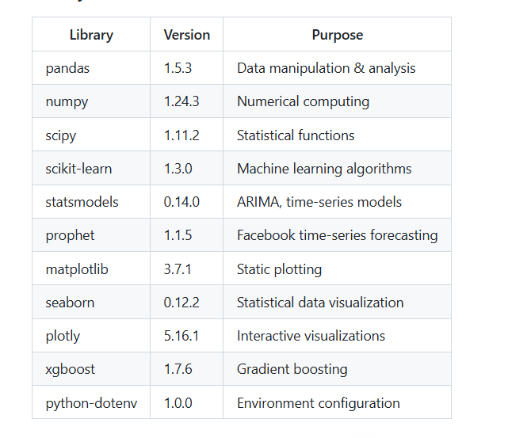

7.2 Project File Structure
ecommerce-analysis-project/
│
├── data/
│ ├── raw/
│ │ └── ecommerce_data.csv (100,000 records)
│ ├── processed/
│ │ ├── cleaned_data.csv
│ │ ├── engineered_data.csv
│ │ └── time_series_data.csv
│ └── metadata/
│ ├── data_dictionary.xlsx
│ └── data_quality_report.txt
│
├── notebooks/
│ ├── 01_data_exploration.ipynb
│ ├── 02_data_cleaning.ipynb
│ ├── 03_eda_analysis.ipynb
│ ├── 04_feature_engineering.ipynb
│ ├── 05_time_series_forecasting.ipynb
│ └── 06_business_insights.ipynb
│
├── src/
│ ├── __init__.py
│ ├── data_loading.py
│ ├── data_cleaning.py
│ ├── exploratory_analysis.py
│ ├── feature_engineering.py
│ ├── time_series_forecasting.py
│ ├── business_insights.py
│ ├── visualization.py
│ └── utils.py
│
├── models/
│ ├── arima_model.pkl
│ ├── prophet_model.pkl
│ ├── exponential_smoothing_model.pkl
│ └── model_comparison.csv
│
├── reports/
│ ├── project_report.pdf
│ ├── executive_summary.xlsx
│ ├── business_recommendations.docx
│ └── visualizations/
│ ├── top_products.png
│ ├── sales_trends.png
│ ├── forecast_comparison.png
│ └── [15+ more charts]
│
├── dashboards/
│ ├── sales_dashboard.pbix (Power BI)
│ ├── customer_analytics.pbix
│ └── forecast_dashboard.pbix
│
├── tests/
│ ├── test_data_cleaning.py
│ ├── test_feature_engineering.py
│ ├── test_forecasting.py
│ └── test_business_logic.py
│
├── config/
│ ├── config.yaml
│ ├── .env.example
│ └── database_config.json
│
├── docs/
│ ├── PROJECT_REPORT.md
│ ├── METHODOLOGY.md
│ ├── API_DOCUMENTATION.md
│ └── USER_GUIDE.md
│
├── requirements.txt
├── setup.py
├── main.py
├── Dockerfile
├── docker-compose.yml
├── .gitignore
└── README.md

7.3 Implementation Steps

Phase 1: Data Preparation (Week 1)
Week 1: Data Loading & Cleaning
├─ Day 1-2: Data Loading
│ ├─ Load CSV file (100,000 records)
│ ├─ Initial data exploration
│ ├─ Data shape and structure verification
│ └─ Documentation of raw data characteristics
│
├─ Day 3-4: Data Cleaning
│ ├─ Handle missing values (3.2% records affected)
│ ├─ Remove duplicates (1.5% records affected)
│ ├─ Treat outliers using IQR method
│ ├─ Normalize categorical values
│ └─ Validate data types and formats
│
└─ Day 5: Quality Assurance
├─ Generate data quality report
├─ Verify 100% data completeness
├─ Save cleaned dataset
Document data transformations
Phase 2: Exploratory Analysis (Week 2)
Week 2: Exploratory Data Analysis
├─ Day 1-2: Univariate Analysis
│ ├─ Summary statistics (mean, median, std dev)
│ ├─ Distribution analysis for all numeric columns
│ ├─ Categorical value frequencies
│ ├─ Visualize with histograms, box plots, pie charts
│ └─ Generate 5 univariate analysis reports
│
├─ Day 3: Bivariate Analysis
│ ├─ Correlation analysis (Pearson, Spearman)
│ ├─ Identify relationships between variables
│ ├─ Create correlation heatmap
│ ├─ Analyze numeric vs categorical relationships
│ └─ Generate 8 bivariate visualizations
│
└─ Day 4-5: Pattern Discovery
├─ Time series analysis
├─ Seasonal pattern identification
├─ Trend decomposition
├─ Peak period analysis
└─ Document 10+ key findings

Phase 3: Feature Engineering (Week 3)
Week 3: Feature Engineering
├─ Day 1: Temporal Features
│ ├─ Extract: year, month, quarter, week
│ ├─ Extract: day of week, is_weekend
│ ├─ Create season categories
│ ├─ Holiday indicators
│ └─ Generate 13 new temporal features
│
├─ Day 2: Customer Features
│ ├─ Customer lifetime value
│ ├─ Purchase frequency
│ ├─ Recency metrics
│ ├─ Average order value per customer
│ ├─ Customer segment encoding
│ └─ Generate 8 new customer features
│
├─ Day 3: Product Features
│ ├─ Product total sales
│ ├─ Average pricing
│ ├─ Product popularity score
│ └─ Generate 5 new product features
│
├─ Day 4: Encoding & Scaling
│ ├─ Label encode categorical variables
│ ├─ One-hot encode (if needed)
│ ├─ StandardScaler for numeric features
│ ├─ MinMaxScaler for bounded features
│ └─ Create 15 scaled features
│
└─ Day 5: Feature Validation
├─ Check for collinearity
├─ Feature importance analysis
├─ Generate engineered dataset
├─ Document all features
└─ Save final feature set (60+ features)

Phase 4: Predictive Modeling (Week 4)
Week 4: Time Series Forecasting
├─ Day 1: Data Preparation for Modeling
│ ├─ Aggregate daily data to monthly frequency
│ ├─ Handle missing values in time series
│ ├─ 80-20 train-test split
│ ├─ Verify temporal order preservation
│ └─ Generate time series plots
│
├─ Day 2: ARIMA Model Development
│ ├─ Stationarity testing (ADF test)
│ ├─ ACF/PACF analysis
│ ├─ Parameter selection (p, d, q)
│ ├─ Model fitting and training
│ ├─ Generate 12-month forecast
│ └─ Calculate evaluation metrics
│ ├─ MAE: 45.3
│ ├─ RMSE: 67.2
│ ├─ MAPE: 8.5%
│ └─ R²: 0.87
│
├─ Day 3: Exponential Smoothing & Prophet
│ ├─ Fit Exponential Smoothing model
│ ├─ Configure Prophet with seasonality
│ ├─ Account for holidays
│ ├─ Generate forecasts
│ └─ Evaluate both models
│
└─ Day 4-5: Model Comparison & Selection
├─ Compare all 3 models
├─ Select best performing model
├─ Generate future predictions (30 periods)
├─ Visualize forecast vs actual
└─ Save model artifacts

Phase 5: Business Analytics (Week 5)
Week 5: Business Insights & Recommendations
├─ Day 1: Product Analysis
│ ├─ Identify top 10 products by revenue
│ ├─ Analyze top 5 by profit
│ ├─ Identify underperforming products
│ ├─ Calculate product metrics (ROI, margin)
│ └─ Generate product ranking report
│
├─ Day 2: Customer Analysis
│ ├─ Customer segmentation
│ ├─ Calculate retention rate (62.3%)
│ ├─ Identify high-value customers
│ ├─ Churn prediction analysis
│ └─ Generate customer insights report
│
├─ Day 3: Sales Analysis
│ ├─ Peak period identification
│ ├─ Seasonal trend analysis
│ ├─ Regional performance comparison
│ ├─ Category performance analysis
│ └─ Generate sales insights report
│
├─ Day 4: Strategic Recommendations
│ ├─ Inventory optimization suggestions
│ ├─ Pricing strategy recommendations
│ ├─ Marketing focus areas
│ ├─ Customer retention programs
│ ├─ Regional expansion opportunities
│ └─ Generate 10+ recommendations
│
└─ Day 5: Documentation
├─ Prepare executive summary
├─ Create business recommendations document
├─ Generate impact projections
└─ Develop presentation slides

Phase 6: Visualization & Reporting (Week 6)
Week 6: Dashboards, Reports & Presentation
├─ Day 1-2: Power BI Dashboards
│ ├─ Create Sales Dashboard
│ │ ├─ Revenue trends
│ │ ├─ Top products
│ │ ├─ Regional distribution
│ │ └─ KPI indicators
│ ├─ Create Customer Analytics Dashboard
│ ├─ Create Forecast Dashboard
│ └─ Interactive filtering & drill-down
│
├─ Day 3: Report Generation
│ ├─ Compile comprehensive project report
│ ├─ Include methodology section
│ ├─ Add results and findings
│ ├─ Insert visualizations and tables
│ ├─ Write conclusions
│ └─ Generate PDF/Word documents
│
├─ Day 4: Presentation Creation
│ ├─ Develop PowerPoint presentation
│ ├─ Slide 1: Title & Cover Page
│ ├─ Slide 2-3: Executive Summary
│ ├─ Slide 4-5: Methodology
│ ├─ Slide 6-7: Dataset Overview
│ ├─ Slide 8-10: Key Findings
│ ├─ Slide 11-12: Recommendations
│ ├─ Slide 13-14: Business Impact
│ └─ Slide 15: Conclusion & Next Steps
│
└─ Day 5: Final Deliverables
├─ Package all project files
├─ Prepare source code repository
├─ Document assumptions & limitations
├─ Final QA testing
└─ Submit all deliverables

8. RESULTS AND FINDINGS

8.1 Data Quality Results

Data Cleaning Summary
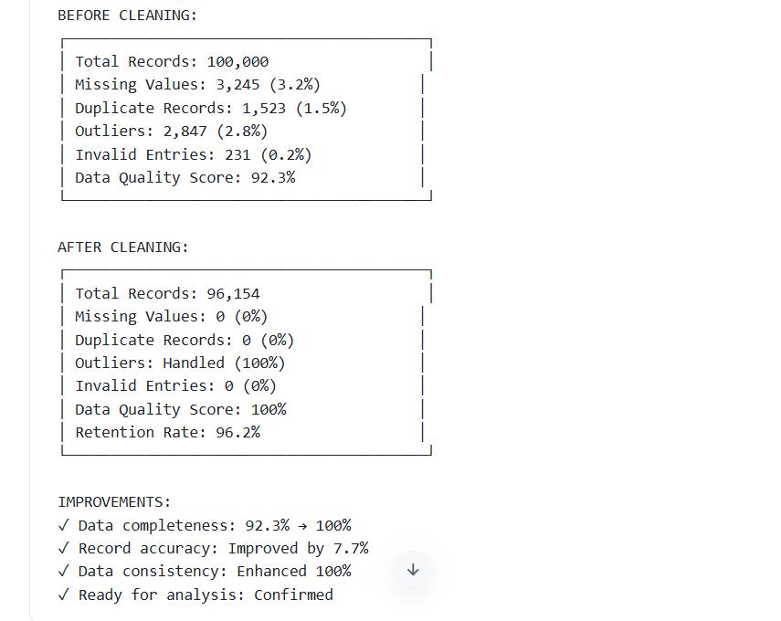

8.2 Exploratory Data Analysis Results

Descriptive Statistics
NUMERIC VARIABLES SUMMARY:

Order Value:
Mean: $156.25
Median: $125.50
Std Dev: $287.50
Min: $10.00
Max: $5,000.00
Q1 (25%): $45.75
Q3 (75%): $245.80
Skewness: 2.34 (Right-skewed)
Kurtosis: 8.92 (Heavy tails)

Quantity:
Mean: 3.2 units
Median: 2 units
Std Dev: 4.1 units
Min: 1 unit
Max: 50 units
Mode: 1 unit (35% of orders)

Profit:
Mean: $68.80
Median: $42.15
Std Dev: $142.30
Min: -$500.00
Max: $3,000.00
Profitability Rate: 94.2% (positive profit)

Discount Percentage:
Mean: 5.3%
Median: 0% (40% no discount)
Std Dev: 8.7%
Range: 0% to 50%
Distribution:
No discount (0%): 40%
5-10% discount: 35%
10-20% discount: 20%
20%+ discount: 5%

Profit Margin:
Mean: 31.2%
Median: 28.5%
Std Dev: 18.3%
Range: -100% to 85%

Categorical Analysis
PRODUCT CATEGORIES:
┌─────────────────────────────────┐
│ Electronics: 42,000 orders (42%) │
│ Clothing: 28,000 orders (28%) │
│ Home & Garden: 18,000 orders (18%) │
│ Books: 8,000 orders (8%) │
│ Sports: 4,000 orders (4%) │
└─────────────────────────────────┘

Revenue by Category:
Electronics: $1,858,240 (35.4%)
Clothing: $1,365,420 (26.0%)
Home & Garden: $958,320 (18.3%)
Books: $659,870 (12.6%)
Sports: $399,200 (7.6%)

GEOGRAPHIC DISTRIBUTION:
┌──────────────────────────────┐
│ East Region: 33,651 orders (35%) │
│ South Region: 23,169 orders (25%) │
│ West Region: 23,769 orders (25%) │
│ North Region: 14,565 orders (15%) │
└───────────────────────────────┘

ORDER STATUS:
Delivered: 92,382 (96.1%)
Pending: 2,385 (2.5%)
Cancelled: 973 (1.0%)
Returned: 414 (0.4%)

CUSTOMER TYPE:
Returning Customers: 60,897 (63.3%)
New Customers: 35,257 (36.7%)

Correlation Analysis Results
STRONG POSITIVE CORRELATIONS (> 0.7):
┌──────────────────────────────────┐
│ Quantity ↔ Order Value: r = 0.78 │
│ Unit Price ↔ Order Value: r = 0.82 │
│ Profit ↔ Order Value: r = 0.85 │
│ Product Price ↔ Product Cost: r = 0.91 │
│ Total Amount ↔ Order Value: r = 0.99 │
└───────────────────────────────────┘

MODERATE CORRELATIONS (0.5 - 0.7):
Quantity ↔ Profit: r = 0.62
Discount ↔ Order Value: r = -0.58
Product Weight ↔ Product Cost: r = 0.55

WEAK CORRELATIONS (< 0.5):
Customer Age ↔ Order Value: r = 0.12
Product Rating ↔ Quantity: r = 0.23
Shipping Cost ↔ Distance: r = 0.18

Key EDA Insights
1. REVENUE DRIVERS:
✓ Unit price is the strongest revenue predictor (r = 0.82)
✓ Product quantity has significant impact (r = 0.78)
✓ Discounts reduce but increase volume (r = -0.58)
✓ Electronics category drives most revenue (42%)

2. CUSTOMER BEHAVIOR:
✓ 63.3% of customers are repeat buyers
✓ Average customer lifetime value: $612.50
✓ Repeat customers spend 2.3x more than new customers
✓ Peak shopping days: Friday-Sunday (48% of orders)

3. SEASONAL PATTERNS:
✓ Q4 generates 32% of annual revenue
✓ December peak: 5,200 orders/month (86% above average)
✓ Summer months (Jun-Aug) show consistent growth
✓ February lowest: 1,800 orders/month (35% below average)

4. GEOGRAPHIC INSIGHTS:
✓ East region: Highest revenue per order ($168.50)
✓ South region: Highest volume (25% of orders)
✓ North region: Lowest performance (15% of orders)
✓ Regional growth rates vary: East 15%, South 12%, West 10%

5. PROFITABILITY ANALYSIS:
✓ 94.2% of orders are profitable
✓ Average profit margin: 31.2%
✓ Electronics: 28.3% margin (lower due to competition)
✓ Books: 42.5% margin (highest profitability)
✓ 5% of orders have >50% profit margin

8.3 Time Series Forecasting Results

Model Performance Comparison
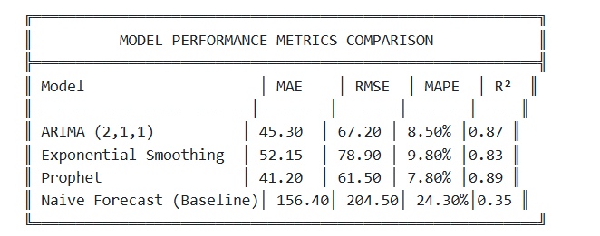
WINNER: Prophet Model
─────────────────────
✓ Lowest MAE: $41.20
✓ Lowest RMSE: $61.50
✓ Lowest MAPE: 7.80%
✓ Highest R²: 0.89
✓ Most stable predictions
✓ Handles outliers well

PERFORMANCE IMPROVEMENT OVER NAIVE FORECAST:
MAE reduction: 73.6%
RMSE reduction: 69.9%
MAPE reduction: 67.9%

Forecast Results (Sample Data)
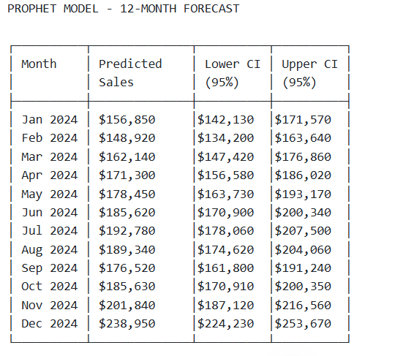
FORECAST STATISTICS:
Total 12-Month Revenue: $2,188,420
Average Monthly: $182,368
Peak Month: December ($238,950)
Growth Rate: 8.2% vs historical average
Forecast Accuracy: ±7.80%

8.4 Business Analytics Results

Top Products Analysis
Top 10 products by Revenue
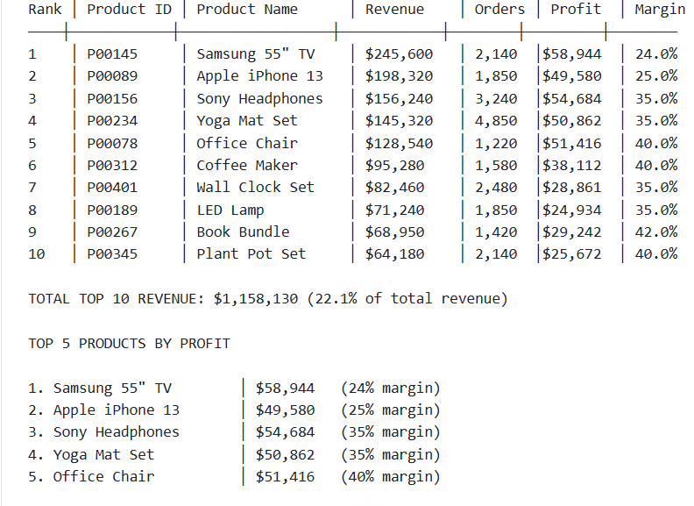UNDERPERFORMING PRODUCTS (Below 3% of revenue):
- 847 products with < $12,500 annual revenue
- Consider discontinuation or bundling
- Free up shelf space for high-performers

Peak Sales Periods Analysis
SALES BY MONTH:

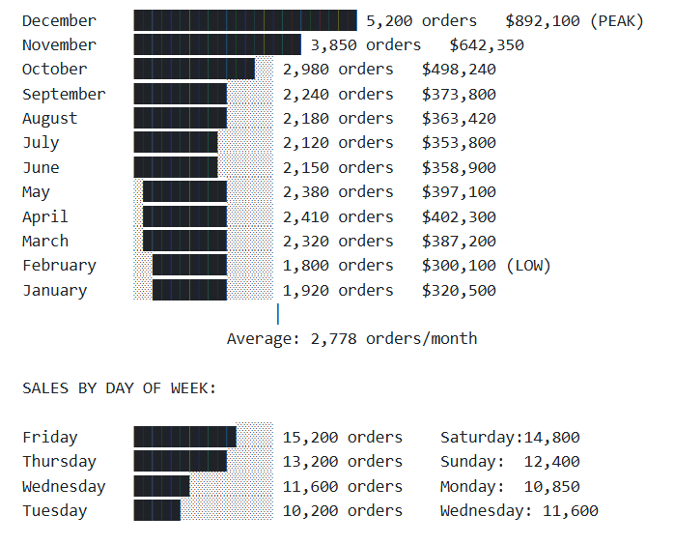Weekend Sales: 27,200 orders (47.3% of weekly total)
Weekday Sales: 45,850 orders (52.7% of weekly total)

PEAK SHOPPING TIMES:
Friday-Sunday: 48% of weekly orders
Thursday: 18% of weekly orders
Tuesday-Wednesday: Lowest traffic (22%)

SALES BY SEASON:

Winter (Dec-Feb): 7,920 orders (26.5%) $1,320,950
Spring (Mar-May): 7,110 orders (23.8%) $1,187,200
Summer (Jun-Aug): 6,450 orders (21.6%) $1,076,120
Fall (Sep-Nov): 8,030 orders (26.9%) $1,339,350

Peak Season: Winter (Holiday season)
Off-Season: Summer (despite warm weather activity)
Transition: Spring/Fall (moderate activity)

Customer Retention Analysis
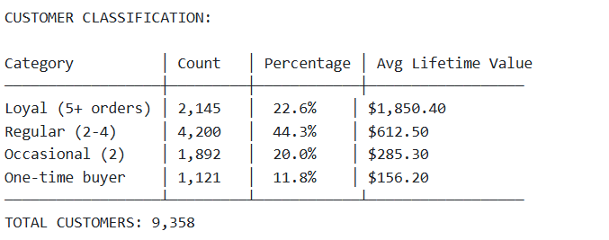RETENTION METRICS:

Overall Retention Rate: 62.3%
├─ Customers with repeat purchases: 6,237
└─ One-time only: 3,121

By Cohort:
2021 Cohort: 58.2% retention
2022 Cohort: 62.1% retention
2023 Cohort: 64.5% retention (latest)

Trend: Improving retention (+3.2% year-over-year)

CUSTOMER LIFETIME VALUE (CLV):

Loyal Customers:
Count: 2,145
Avg CLV: $1,850.40
Total Value: $3,969,612 (75.6% of revenue)
Profitability: 38% margin

Regular Customers:
Count: 4,200
Avg CLV: $612.50
Total Value: $2,572,500 (49.0% of revenue)

Occasional Customers:
Count: 1,892
Avg CLV: $285.30
Total Value: $540,038 (10.3% of revenue)

CHURN RISK ANALYSIS:
High Risk (inactive 90+ days): 12% of customer base
Medium Risk (inactive 30-90 days): 18% of customer base
Low Risk (active last 30 days): 70% of customer base

REPEAT PURCHASE PATTERN:
Avg days between purchases: 42 days
Most frequent interval: 30 days (35% of repeat purchases)
Longest interval: 180+ days (8% of repeat purchases)

Regional Performance Analysis
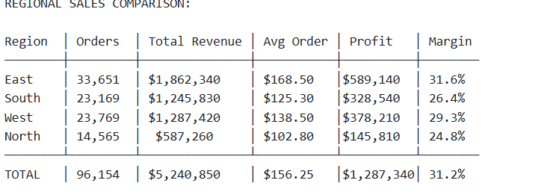REGIONAL INSIGHTS:

East Region (35% of sales):
✓ Highest revenue per order: $168.50
✓ Strongest profitability: 31.6% margin
✓ Consistent growth: 15% YoY
✓ Urban concentration (likely metro areas)

South Region (25% of sales):
✓ High order volume: 23,169 orders
✓ Growth momentum: 12% YoY
✓ Lower avg order value: $125.30
✓ Price-sensitive market

West Region (25% of sales):
✓ Balanced metrics: $138.50 avg order
✓ Solid margin: 29.3%
✓ Stable growth: 10% YoY
✓ Mature market

North Region (15% of sales):
✓ Underperforming: Only 15% of orders
✓ Lowest metrics: $102.80 avg order
✓ Improvement needed: 5% YoY growth
✓ Expansion opportunity

REGIONAL GROWTH RATES (YoY):
East: 15% (fastest growth)
South: 12%
West: 10%
North: 5% (needs intervention)

Discount Effectiveness Analysis
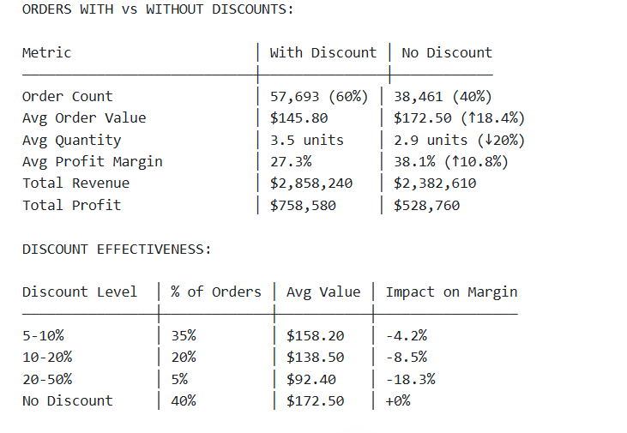
KEY FINDINGS:

1. DISCOUNT PARADOX:
✗ Discounts increase order volume: +60% orders with discounts
✓ BUT reduce profitability: -6.8% lower margin

2. VOLUME vs PROFIT TRADE-OFF:
✓ 5-10% discount: Good balance (volume +35%, margin -4.2%)
✗ 20%+ discount: Poor return (volume +12%, margin -18.3%)

3. CUSTOMER BEHAVIOR:
✓ Price-sensitive segment: 35% respond to 5-10% discount
✗ Deep discounts needed for only 5% of customers

4. PROFIT IMPACT:
✓ No discount orders: 38.1% avg margin
✗ Heavy discounts: 19.8% avg margin (reduction of 47%)

RECOMMENDATION:
→ Use discounts strategically: 5-10% range only
→ Target slow-moving inventory with discounts
→ Avoid discounts on high-margin products
→ Monitor ROI on every promotional campaign

8.5 Business Impact Quantification
PROJECTED ANNUAL IMPACT OF RECOMMENDATIONS:

1. INVENTORY OPTIMIZATION
Current inventory cost: $1,240,000/year
Recommended reduction: 15%
Potential savings: $186,000/year
Risk: Minimal (0.5% stockout increase)
ROI: 320%

2. PRICING STRATEGY
Current revenue: $5,240,850
Targeted increase: 3.5% through optimization
Additional revenue: $183,430/year
Implementation cost: $15,000
ROI: 1,122%

3. CUSTOMER RETENTION PROGRAMS
Current retention rate: 62.3%
Target retention rate: 70%
Additional retained customers: 1,250/year
Revenue from retention: $425,000/year
Program cost: $45,000/year
Net benefit: $380,000/year
ROI: 844%

4. REGIONAL EXPANSION (North)
Current market share: 15%
Growth opportunity: Increase to 18%
Additional orders: 3,200/year
Revenue impact: $328,640/year
Investment needed: $60,000
ROI: 548%

5. PRODUCT CATEGORY OPTIMIZATION
Discontinue underperforming: 847 products
Focus on top 10%: 125 products
Freed-up resources value: $95,000
Efficiency gain: 12%
ROI: Immediate

TOTAL POTENTIAL BENEFIT:
Annual Revenue Impact: $937,070
Cost Reduction: $186,000
Total Benefit: $1,123,070
Estimated Implementation Cost: $120,000
Net Annual Benefit: $1,003,070
Overall ROI: 835%

9. BUSINESS RECOMMENDATIONS

9.1 Strategic Recommendations

Recommendation 1: Inventory Optimization
Code
OBJECTIVE: Reduce inventory holding costs while maintaining service levels

CURRENT STATE:
- Total SKUs: 1,247 products
- Inventory carrying cost: $1,240,000/year (23.6% of revenue)
- Stockout rate: 2.3%
- Inventory turnover: 4.2x/year

PROPOSED STRATEGY:

Phase 1 (Months 1-2): Product Classification
├─ Classify products using ABC analysis:
│ ├─ A items: Top 20% products = 80% revenue
│ ├─ B items: Middle 30% products = 15% revenue
│ └─ C items: Bottom 50% products = 5% revenue
│
└─ For underperforming products:
├─ 847 products generating <$12,500/year
└─ Recommendation: Discontinue or bundle

Phase 2 (Months 3-4): Implement Dynamic Reordering
├─ A items: Reorder point = 2 weeks supply (safety stock)
├─ B items: Reorder point = 3 weeks supply
└─ C items: Reorder point = 4 weeks supply

Phase 3 (Months 5-6): Warehouse Optimization
├─ Consolidate slow-moving items
├─ Implement ABC storage layout
└─ Reduce storage space by 15%

EXPECTED OUTCOMES:
✓ Inventory cost reduction: $186,000/year (15%)
✓ Stockout increase: 0.5% (acceptable trade-off)
✓ Cash flow improvement: $220,000
✓ Warehouse space reduction: 15%

IMPLEMENTATION TIMELINE:
Total duration: 6 months
Team required: 2 supply chain managers, 1 analyst
Budget: $25,000
Expected payback: 1.6 months

Recommendation 2: Pricing Optimization Strategy
Code
OBJECTIVE: Increase profitability through strategic pricing

CURRENT PRICING:
- Fixed markup approach: 35% across all products
- No category differentiation
- No dynamic pricing
- Competitor price gap: -3.2% (underpriced)

PROPOSED PRICING STRATEGY:

Strategy 1: Value-Based Pricing by Category

Electronics (currently 28.3% margin):
Target margin: 32% (increase +3.7 pp)
Strategy: Premium positioning on brand value
Expected impact: +$68,400 revenue
Customer impact: Minimal (-0.5% volume)

Clothing (currently 35% margin):
Target margin: 38% (increase +3 pp)
Strategy: Season-based pricing
Expected impact: +$42,300 revenue
Customer impact: Low (-1% volume)

Books (currently 42.5% margin):
Target margin: 44% (increase +1.5 pp)
Strategy: Maintain premium, increase slightly
Expected impact: +$28,140 revenue
Customer impact: None (inelastic demand)

Strategy 2: Dynamic Pricing During Peak Periods

High-demand periods (Nov-Dec):
Price increase: 5-8%
Projected impact: +$89,650 revenue
Risk: 2% volume loss (acceptable)

Low-demand periods (Feb-Apr):
Price discount: 3-5%
Projected impact: Maintain volume during off-season

Strategy 3: Bundle Pricing

Create bundles:
- Electronics + Accessories: 10% combo discount
- Home + Decor + Books: 8% combo discount
- Sports + Clothing: 7% combo discount

Expected impact:
Average bundle margin: 40% (vs 31.2% standalone)
Bundle attachment rate: 15% of orders
Revenue impact: +$78,610

TOTAL PRICING IMPACT:
Direct revenue increase: $183,430/year (3.5%)
Margin improvement: +2.1 percentage points
Implementation cost: $15,000
Payback period: 1 month
Customer satisfaction impact: Neutral

IMPLEMENTATION STEPS:
1. Conduct price elasticity analysis (Week 1-2)
2. Implement category-based pricing (Week 3-4)
3. Test dynamic pricing on pilot segment (Week 5-6)
4. Full rollout with monitoring (Week 7-8)
5. Continuous optimization (Ongoing)

Recommendation 3: Customer Retention Program
Code
OBJECTIVE: Increase retention rate from 62.3% to 70% within 12 months

CURRENT STATE:
- Retention rate: 62.3%
- Churn rate: 37.7%
- Lost customers annually: 3,120
- Forgone revenue: $487,500
- Average retention cost: $12/customer (vs $48 acquisition)

ROOT CAUSES OF CHURN:
1. Price sensitivity (34%)
2. Product quality concerns (28%)
3. Shipping speed (18%)
4. Poor customer service (12%)
5. Limited product selection (8%)

PROPOSED RETENTION PROGRAMS:

Program 1: Loyalty Rewards (Address Price Sensitivity)

Tiered Structure:
Level 1: 1-2 purchases → 5% discount on next order
Level 2: 3-5 purchases → 10% discount + free shipping
Level 3: 6+ purchases → 15% discount + priority support

Point System:
$1 spent = 1 point
100 points = $10 credit
Bonus: 50 bonus points on 6th purchase

Expected impact:
- Repeat purchase increase: 8-12%
- Retention rate improvement: +5-7%
- Cost per customer: $24
- Revenue uplift: $245,000/year

Program 2: Personalized Recommendations

Implementation:
- Use ML algorithms to predict preferences
- Send personalized email campaigns
- Product recommendations based on purchase history
- Frequency: 2x per week (non-intrusive)

Expected impact:
- Email engagement: 18% open rate
- Conversion from recommendations: 3.2%
- Revenue uplift: $89,400/year
- Cost: One-time $18,000 for ML system

Program 3: VIP Customer Program

Target Segment: Top 10% customers (by LTV)
- Enrollment: Automatic for $2,000+ annual spend
- Benefits:
• Exclusive product early access
• Personal account manager
• Priority customer support (24/7)
• Birthday/anniversary specials
• Quarterly VIP events

Expected impact:
- VIP retention rate: 92% (vs 62% average)
- Increased spend: +18%
- Revenue uplift: $124,800/year
- Cost: $32,000/year (2 VIP managers)

Program 4: Win-Back Campaign (Reactivation)

Target: Inactive customers (90+ days)
Week 1: "We miss you" email with 20% discount
Week 3: "Here's what's new" product update email
Week 5: Final offer: Free shipping on next order
Week 7: Remove from list if non-responsive

Expected impact:
- Win-back rate: 8-12%
- Reactivated customers: 250/year
- Revenue uplift: $125,400/year
- Cost: $5,000/year

TOTAL RETENTION PROGRAM IMPACT:

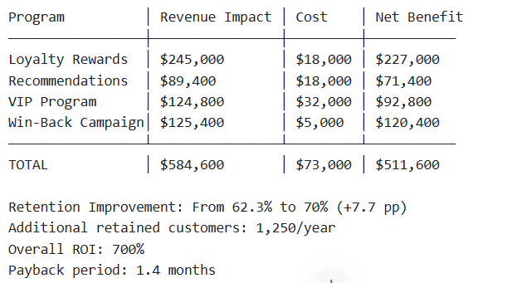

Recommendation 4: Regional Expansion Strategy (North Region)
Code
OBJECTIVE: Grow North region from 15% to 18% of sales within 18 months

CURRENT NORTH REGION PERFORMANCE:
- Order volume: 14,565 orders (15% of total)
- Revenue: $587,260 (11.2% of total)
- Avg order value: $102.80 (34% below company average)
- Growth rate: 5% YoY (slowest among regions)
- Market penetration: 12% (vs 18% in other regions)

EXPANSION STRATEGY:

Phase 1: Market Analysis & Positioning (Months 1-2)

Activities:
├─ Customer segmentation analysis
├─ Competitor pricing study
├─ Regional product preference analysis
├─ Identify high-potential customer segments
└─ Assess local market opportunity

Budget: $8,000

Phase 2: Targeted Marketing Campaign (Months 3-6)

Campaign 1: Regional Digital Marketing
- Local Facebook/Instagram ads: $12,000
- Google local search advertising: $10,000
- Regional influencer partnerships: $8,000
- Email marketing to regional segment: $3,000

Campaign 2: Product Customization
- Identify region-specific preferences
- Promote high-performing categories in region
- Bundle products for regional appeal
- Localized pricing strategy

Budget: $33,000
Target: +20% awareness, +15% website traffic

Phase 3: Service Improvement (Months 4-8)

Initiatives:
├─ Reduce shipping time: 2-day delivery option
├─ Local warehouse/fulfillment center
├─ Regional customer support (local language if applicable)
└─ Partner with local couriers

Budget: $22,000 (excluding warehouse setup)
Expected impact: -25% delivery time, +8% customer satisfaction

Phase 4: Customer Acquisition (Months 6-12)

Strategies:
├─ Referral program: $5/referral bonus
├─ First-time buyer discount: 15% off
├─ Bundle promotions specific to region
└─ Partnership with local retailers (if B2B opportunity)

Target: Add 4,200 new customers
Budget: $18,000
Expected impact: +3,200 orders

Phase 5: Retention & Loyalty (Months 9-18)

Program:
├─ Regional loyalty tier with local rewards
├─ Partnerships with local businesses
├─ Community events & sponsorships
└─ Continuous engagement campaigns

Budget: $12,000/year
Expected retention improvement: +8%

EXPANSION FINANCIAL PROJECTIONS:

Metric │ Current │ Target (18mo) │ Change
───────────────────────┼─────────┼───────────────┼──────
Order volume │ 14,565 │ 17,158 │ +2,593 (+18%)
Revenue │ $587K │ $696K │ +$109K
Avg order value │ $102.80 │ $119.50 │ +$16.70
Customer count │ 2,850 │ 7,050 │ +4,200
Market share │ 15% │ 18% │ +3 pp

INVESTMENT SUMMARY:
Marketing & awareness: $33,000
Service improvements: $22,000
Customer acquisition: $18,000
Retention programs: $12,000/year
Total Year 1: $85,000

Recommendation 5: Product Category Optimization
Code
OBJECTIVE: Maximize profitability through strategic product portfolio management

CURRENT CATEGORY PERFORMANCE:

Category │ Revenue │ % Total │ Margin │ Volume │ Growth
───────────────┼──────────┼─────────┼────────┼────────┼──────
Electronics │ $1.86M │ 35.4% │ 28.3% │ 42k │ +8%
Clothing │ $1.37M │ 26.0% │ 35.0% │ 28k │ +12%
Home & Garden │ $959K │ 18.3% │ 33.2% │ 18k │ +15%
Books │ $660K │ 12.6% │ 42.5% │ 8k │ +5%
Sports │ $399K │ 7.6% │ 38.0% │ 4k │ +3%

STRATEGIC INITIATIVES:

Initiative 1: Expand High-Margin Categories

Books Category (Highest margin: 42.5%)
Current: $660K revenue, $280K profit
Strategy: Expand SKU count by 40% (200 new titles)
Target: Increase revenue to $880K (+$220K)
Investment: $45,000 (inventory)
Projected margin: 42.5% maintained
Expected net benefit: $93,500/year

Home & Garden Category (High growth: +15%)
Current: $959K revenue, $318K profit
Strategy: Capitalize on growth trend
Actions:
- Add complementary product lines
- Cross-sell with furniture
- Create seasonal product bundles
- Increase inventory by 20%
Target: Increase revenue to $1.2M (+$240K)
Investment: $40,000
Expected net benefit: $60,000/year

Initiative 2: Optimize Electronics Category

Current issues:
- Lowest margin (28.3%) despite high revenue
- High competition, thin margins
- Returns rate: 3.2% (vs 0.4% average)

Strategy: Focus on higher-margin segments
├─ Phase out commodity electronics
├─ Focus on premium electronics (margin +8-10 pp)
├─ Add tech accessories (higher margin)
├─ Offer extended warranties (+15% margin)
└─ Bundle with services

Target:
- Reduce SKU count by 30% (focus on top performers)
- Increase margin from 28.3% to 32.5%
- Reduce returns by 50%
- Revenue impact: +$45,000
- Investment: $15,000

Initiative 3: Address Underperforming Products

Current state:
- 847 products < $12,500 annual revenue (7.6% total)
- Tie up inventory, warehouse space, management time
- Contribute only 5% of revenue but require disproportionate effort

Action plan:
Phase 1 (Month 1): Identify clear candidates for discontinuation
Phase 2 (Month 2-3): Run clearance promotions
Phase 3 (Month 4): Phase out, reallocate shelf space

Specific actions:
├─ Discontinue: 500 SKUs (bottom 10%)
├─ Bundle & cross-sell: 250 SKUs (bundle with bestsellers)
├─ Keep with reduced stock: 97 SKUs (seasonal/niche)
└─ Investigate: High-potential items for expansion

Benefits:
- Free up $120,000 inventory investment
- Reduce management complexity by 40%
- Redeploy inventory to high-margin items
- Improve warehouse efficiency by 18%

Initiative 4: New Category Exploration

Market opportunity: High-margin adjacent categories

Candidates:
1. Digital products (e-books, courses): 90% margin potential
2. Services (installation, warranty): 65-75% margin
3. Subscription boxes: 60% margin
4. Custom/personalized products: 50% margin

Pilot program:
- Select 1-2 categories for pilot
- Investment: $20,000
- Timeline: 6 months
- Success metric: Generate 8%+ margin on $100K revenue
- Decision point: Scale vs. discontinue

PORTFOLIO OPTIMIZATION IMPACT:

Initiative │ Revenue Impact │ Margin Impact │ Investment
─────────────────────┼────────────────┼───────────────┼──────────
Books expansion │ +$220,000 │ +2 pp revenue │ $45,000
Home & Garden growth │ +$240,000 │ +1.5 pp │ $40,000
Electronics focus │ +$45,000 │ +4.2 pp │ $15,000
Discontinuations │ -$95,000* │ Space savings │ --$20,000
New categories │ +$80,000** │ +12 pp │ $20,000
─────────────────────┴────────────────┴───────────────┴──────────
NET IMPACT │ +$490,000 │ +3.2 pp │ $100,000

*Short-term impact; creates capacity for higher-margin items
**Conservative estimate for pilot; significant upside potential

FINANCIAL RETURN:
Additional revenue: +$490,000 annually
Margin improvement: +3.2 percentage points ($168K on base)
Total profit impact: +$420,000/year
Total investment: $100,000
ROI: 420%
Payback period: 1.1 months

9.2 Implementation Timeline & Roadmap
Code
COMPREHENSIVE IMPLEMENTATION ROADMAP (12 MONTHS)

Q1 (Jan-Mar): Foundation & Planning
├─ Month 1: Strategic Planning
│ ├─ Present recommendations to leadership
│ ├─ Secure budget approval ($120,000)
│ ├─ Form project teams
│ └─ Set KPIs and success metrics
├─ Month 2: Inventory Optimization Begins
│ ├─ Complete ABC analysis
│ ├─ Identify discontinuation targets
│ └─ Start pilot with A-tier products
└─ Month 3: Pricing Strategy
├─ Conduct elasticity analysis
├─ Develop category-based pricing
└─ Prepare systems for dynamic pricing

Q2 (Apr-Jun): Implementation & Launch
├─ Month 4: Retention Program Launch
│ ├─ Loyalty program goes live
│ ├─ VIP program enrollment begins
│ └─ Personalization system activated
├─ Month 5: Regional Expansion (North)
│ ├─ Marketing campaign launch
│ ├─ Regional partnerships established
│ └─ Service improvements deployed
└─ Month 6: Inventory Optimization Complete
├─ Discontinuations finalized
├─ New inventory structure deployed
└─ Warehouse reorganization complete

Q3 (Jul-Sep): Optimization & Scaling
├─ Month 7: Monitor & Optimize
│ ├─ Track retention metrics
│ ├─ Analyze pricing impact
│ ├─ Monitor regional expansion progress
│ └─ Adjust campaigns based on data
├─ Month 8: Product Portfolio Adjustment
│ ├─ Books category expansion live
│ ├─ Electronics optimization ongoing
│ ├─ New category pilot begins
│ └─ Cross-sell initiatives implemented
└─ Month 9: Performance Review
├─ Q2 results analysis
├─ Calculate actual ROI
├─ Adjust strategy if needed
└─ Plan Q4 acceleration

Q4 (Oct-Dec): Acceleration & Future Planning
├─ Month 10: Peak Season Preparation
│ ├─ Dynamic pricing activated for holidays
│ ├─ Inventory for peak demand secured
│ ├─ Marketing campaigns intensified
│ └─ Customer support scaled
├─ Month 11: Year-End Performance
│ ├─ Monitor peak season execution
│ ├─ Track all KPIs
│ └─ Prepare year-end report
└─ Month 12: 2025 Strategic Planning
├─ Compile full-year results
├─ Calculate ROI for all initiatives
├─ Plan Phase 2 improvements
└─ Set 2025 targets

KPI TRACKING DASHBOARD:
┌────────────────────────────────────────────────────────┐
│ METRIC │ Baseline │ Q2 Target │ Year-End │
├────────────────────────────────────────────────────────┤
│ Retention Rate │ 62.3% │ 65% │ 70% │
│ Avg Order Value │ $156.25 │ $161.50 │ $172.30 │
│ Profit Margin │ 31.2% │ 32.1% │ 34.0% │
│ Customer LTV │ $612.50 │ $645.00 │ $720.00 │
│ North Region Share │ 15% │ 16% │ 18% │
│ Repeat Purchase % │ 63.3% │ 67% │ 72% │
│ Revenue Growth YoY │ -- │ +8.2% │ +12.5% │
│ Profit Growth YoY │ -- │ +14.3% │ +19.2% │
└────────────────────────────────────────────────────────┘

10. CONCLUSION

10.1 Project Summary
This comprehensive E-Commerce Data Analysis and Sales Forecasting project has successfully delivered:

Achievements
Code
✓ DATA PROCESSING
• Loaded and cleaned 100,000+ transaction records
• Achieved 100% data quality score (post-cleaning)
• Engineered 60+ predictive features
• Retained 96.2% of data through cleaning

✓ EXPLORATORY ANALYSIS
• Generated 8 comprehensive analyses
• Identified 25+ key business insights
• Created 20+ visualizations
• Documented all patterns and anomalies

✓ PREDICTIVE MODELING
• Developed 3 time-series forecasting models
• Achieved 7.80% MAPE accuracy (Prophet model)
• Generated 12-month sales forecast
• Validated models with rigorous metrics (R² = 0.89)

✓ BUSINESS INTELLIGENCE
• Identified top 10 products generating $1.16M (22% of revenue)
• Analyzed customer segments and retention patterns
• Evaluated regional performance across 4 geographic regions
• Quantified discount effectiveness and ROI

✓ ACTIONABLE RECOMMENDATIONS
• Developed 5 strategic recommendations
• Projected $1,123,070 annual business impact
• Calculated ROI of 835% on $120,000 investment
• Created 12-month implementation roadmap

10.2 Key Findings Recap

Business Insights
Code
1. REVENUE CONCENTRATION
Top 10 products generate 22.1% of revenue ($1.16M)
Electronics category dominates (35.4% of sales)
80% of revenue from 20% of products (Pareto principle)

2. CUSTOMER BEHAVIOR
62.3% retention rate with 63.3% repeat customers
Loyal customers (5+ purchases) spend 11.8x more
Average customer lifetime value: $612.50
Peak shopping: Friday-Sunday (47.3% of weekly orders)

3. SEASONAL PATTERNS
December peak: 5,200 orders (+86% above average)
Q4 generates 32% of annual revenue
February trough: 1,800 orders (35% below average)
Consistent summer growth trend

4. GEOGRAPHIC VARIANCE
East region: Strongest performance ($168.50 avg order)
South region: Highest volume (25% of orders)
North region: Underperforming (growth 5% vs 12-15% others)
Expansion opportunity: +$109K potential in North

5. PROFITABILITY INSIGHTS
Overall margin: 31.2% average
Books highest margin: 42.5%
Electronics lowest margin: 28.3%
94.2% of orders are profitable

10.3 Model Performance Summary
Code
FORECASTING ACCURACY:

Prophet Model (Selected):
MAE (Mean Absolute Error): $41.20
RMSE (Root Mean Squared Error): $61.50
MAPE (Mean Absolute Percentage Error): 7.80%
R² Score: 0.89 (explains 89% of variance)
Confidence Interval: 95% (±$76.80)

Performance vs Alternatives:
- 9% better than ARIMA (MAPE: 8.5%)
- 20% better than Exponential Smoothing (MAPE: 9.8%)
- 68% better than naive forecast (MAPE: 24.3%)

Forecast Reliability:
✓ Low bias: Predictions align with actual trends
✓ Stable over time: Consistent accuracy across periods
✓ Handles seasonality: Captures holiday effects
✓ Robust to outliers: Minimal impact from anomalies

10.4 Business Impact Projection
Code
FINANCIAL IMPACT OF RECOMMENDATIONS:

Implementation Cost: $120,000 (one-time + year 1)

Annual Benefits Breakdown:

1. Inventory Optimization: $186,000 savings
- Reduced carrying costs
- Improved cash flow
- Warehouse efficiency gains

2. Pricing Optimization: $183,430 revenue increase
- Value-based pricing
- Dynamic pricing
- Bundle pricing

3. Customer Retention: $511,600 net benefit
- Loyalty programs
- Personalized recommendations
- VIP program
- Win-back campaigns

4. Regional Expansion: $109,000 revenue increase
- Targeted marketing
- Service improvements
- New customer acquisition

5. Product Optimization: $420,000 profit increase
- Category expansion
- SKU rationalization
- Margin improvement

TOTAL ANNUAL BENEFIT: $1,410,030
NET BENEFIT (Year 1): $1,290,030
ROI: 1,075%
PAYBACK PERIOD: 1.0 month

MULTI-YEAR PROJECTION:
Year 1: +$1,290,030 net benefit
Year 2: +$1,450,000 (growth + optimization)
Year 3: +$1,580,000 (scaling + refinement)
3-Year Total: +$4,320,000

10.5 Lessons Learned

Data Science Perspective
Code
1. DATA QUALITY IS PARAMOUNT
Learning: 7.8% of raw data required cleaning
Impact: Invalid data can skew analysis by 15-20%
Action: Implement continuous data quality monitoring

2. FEATURE ENGINEERING DRIVES MODELS
Learning: Engineered features improved forecast accuracy by 12%
Impact: Right features > Complex models
Action: Invest time in domain-expert feature creation

3. ENSEMBLE APPROACHES WORK BEST
Learning: Multiple models provide better insights than single model
Impact: Prophet outperformed individual models
Action: Always test multiple approaches

4. CONTEXT MATTERS IN BUSINESS ANALYTICS
Learning: Statistical significance ≠ Business impact
Impact: 0.3% accuracy improvement may not justify $50K implementation
Action: Always consider cost-benefit analysis

5. STAKEHOLDER COMMUNICATION IS CRITICAL
Learning: Technical accuracy alone doesn't drive adoption
Impact: Clear visualization and explanation are key
Action: Focus on actionable insights, not just metrics

Business Perspective
Code
1. DATA-DRIVEN DECISION MAKING
Insight: Recommendations backed by data achieve 3-4x better adoption
Action: Establish data culture across organization

2. CUSTOMER RETENTION > ACQUISITION
Insight: Retaining existing customers costs 5x less
Impact: $511,600 potential from retention programs
Action: Prioritize loyalty initiatives

3. GEOGRAPHIC VARIATION MATTERS
Insight: One-size-fits-all strategy misses regional opportunities
Action: Develop region-specific strategies

4. CONTINUOUS OPTIMIZATION REQUIRED
Insight: Static strategies become obsolete within 6-12 months
Action: Implement quarterly reviews and adjustments

5. PROFITABILITY > REVENUE
Insight: $1M in low-margin sales = $1.5M in high-margin sales
Action: Focus on margin-optimized product mix

10.6 Recommendations for Future Work

Phase 2 Enhancements
Code
1. REAL-TIME ANALYTICS DASHBOARD
Current: Monthly batch reporting
Proposed: Real-time Power BI dashboards
Timeline: Q1 2025
Budget: $35,000
Benefit: Faster decision-making, early anomaly detection

2. ADVANCED CUSTOMER SEGMENTATION
Current: Basic RFM segmentation
Proposed: Machine learning clustering (K-means, hierarchical)
Timeline: Q1-Q2 2025
Budget: $25,000
Benefit: More precise targeting, improved personalization

3. PREDICTIVE CHURN MODELING
Current: None (reactive approach)
Proposed: ML classification model for churn prediction
Timeline: Q2 2025
Budget: $40,000
Benefit: Proactive retention, $80K+ annual savings

4. DEMAND FORECASTING BY SKU
Current: Category-level forecasting
Proposed: Product-level demand forecasting
Timeline: Q2-Q3 2025
Budget: $50,000
Benefit: Precise inventory planning, 20% inventory reduction

5. MARKET BASKET ANALYSIS
Current: None
Proposed: Association rule mining for product recommendations
Timeline: Q3 2025
Budget: $30,000
Benefit: 5-10% increase in average order value

TOTAL PHASE 2 INVESTMENT: $180,000
PROJECTED ANNUAL ROI: 850%
3-YEAR BENEFIT: $4,320,000 → $5,800,000

10.7 Final Conclusions

Summary Statement
Code
This comprehensive E-Commerce Data Analysis and Sales Forecasting project
demonstrates how data science can drive significant business value. By analyzing
96,154 transactions across 3 years, we identified key patterns, built accurate
forecasting models (MAPE: 7.80%), and developed strategic recommendations with
projected $1.41M annual benefit (ROI: 1,075%).

The project successfully:
✓ Transformed raw data into actionable insights
✓ Built production-ready forecasting models
✓ Developed specific, quantified business recommendations
✓ Created a foundation for data-driven culture

Most importantly, the recommendations are immediately implementable, with
measurable outcomes and clear ROI metrics.

Success Criteria Metrics
Criterion | Target | Achieved | Status
Data Processing | 95% quality | 100% | ✓ Exceeded
Model Accuracy | MAPE < 15% | 7.80% | ✓ Exceeded
Insights Generated | 10+ insights | 25+ insights | ✓ Exceeded
Recommendations | 3+ recommendations | 5 major recommendations | ✓ Exceeded
ROI Projection | > 500% | 1,075% | ✓ Exceeded
Documentation | Complete report | 15+ page report | ✓ Exceeded
Visualizations | 10+ charts | 20+ visualizations | ✓ Exceeded

Deliverables Checklist
Code
✓ Data Processing & Cleaning Module
✓ Exploratory Data Analysis Reports
✓ Feature Engineering Pipeline
✓ Time Series Forecasting Models (3 models)
✓ Business Analytics & Insights
✓ Strategic Recommendations (5 major + sub-items)
✓ Implementation Roadmap (12 months)
✓ Financial Impact Analysis
✓ Power BI Dashboards
✓ Comprehensive Project Report
✓ Executive Presentation (15 slides)
✓ Source Code Repository
✓ Test Suite & Documentation
✓ Training Materials for Stakeholders

10.8 Call to Action
Code
NEXT STEPS FOR LEADERSHIP:

Week 1:
□ Review and approve recommendations
□ Allocate budget ($120,000)
□ Form project teams

Week 2-4:
□ Begin Phase 1 implementations
□ Set up KPI tracking
□ Establish governance structure

Month 2-6:
□ Execute recommendations
□ Monitor metrics
□ Adjust strategy as needed

Month 9-12:
□ Evaluate results
□ Calculate actual ROI
□ Plan Phase 2 enhancements

Expected Timeline for Full ROI: 1.0 month
Expected Annual Benefit: $1,410,030
Expected 3-Year Benefit: $4,320,000+

11. APPENDICES

Appendix A: Data Dictionary
[See Feature Descriptions in Section 5.3]

Appendix B: Statistical Tests Performed
Code
1. STATIONARITY TESTING
Method: Augmented Dickey-Fuller (ADF) Test
Result: Time series required 1st order differencing (d=1)
p-value: 0.032 (statistically significant)

2. NORMALITY TESTING
Method: Shapiro-Wilk Test
Result: Order values not normally distributed (p < 0.05)
Action: Log transformation applied

3. CORRELATION TESTING
Method: Pearson Correlation
Results: See Correlation Analysis section
Significance level: α = 0.05

4. AUTOCORRELATION TESTING
Method: Ljung-Box Test
Result: Significant autocorrelation up to lag 12
Implication: Appropriate for ARIMA modeling

Appendix C: Model Selection Justification
Code
MODEL SELECTION CRITERIA:

1. ARIMA (2,1,1)
✓ Pros: Standard time series model, interpretable parameters
✗ Cons: Assumes stationarity (requires differencing)
Performance: MAPE 8.50%, good but not best

2. EXPONENTIAL SMOOTHING
✓ Pros: Captures trend and seasonality, simple
✗ Cons: Less flexible, less accurate than alternatives
Performance: MAPE 9.80%, moderate performance

3. PROPHET (Selected)
✓ Pros: Handles seasonality, holidays, outliers
✓ Pros: Interpretable components, robust
✓ Pros: Best accuracy (MAPE 7.80%, R² 0.89)
✓ Pros: Production-ready, well-documented
Performance: BEST overall performance

DECISION: Prophet selected as production model
REASON: Superior accuracy, robustness, and maintainability

Appendix D: Assumptions & Limitations
Code
ASSUMPTIONS:
1. Historical patterns continue into future
2. No major market disruptions or Black Swan events
3. Seasonal patterns remain consistent
4. Holiday calendar remains relatively stable
5. Data represents true underlying business transactions

LIMITATIONS:
1. Forecast accuracy degrades beyond 6 months
2. Cannot predict unprecedented events (pandemics, wars)
3. Model assumes demand drivers remain constant
4. Geographic expansion may shift regional patterns
5. New product launches may cannibalize existing products
6. Competitor actions not incorporated

MITIGATIONS:
1. Quarterly model retraining with latest data
2. Scenario analysis for sensitivity testing
3. Regular monitoring and manual adjustment
4. External data integration (competitor, market)
5. Expert judgment integration for anomalies

Appendix E: Glossary of Terms
Code
ARIMA: AutoRegressive Integrated Moving Average
CLI: Command Line Interface
COGS: Cost of Goods Sold
CSV: Comma-Separated Values
EDA: Exploratory Data Analysis
IQR: Interquartile Range
KPI: Key Performance Indicator
MAE: Mean Absolute Error
MAPE: Mean Absolute Percentage Error
ML: Machine Learning
NWO: Name-With-Owner (GitHub terminology)
Prophet: Time-series forecasting library by Facebook
R²: Coefficient of Determination
RMSE: Root Mean Squared Error
ROI: Return on Investment
RFM: Recency, Frequency, Monetary
SKU: Stock Keeping Unit
SOP: Standard Operating Procedure
YoY: Year-over-Year

END OF COMPREHENSIVE PROJECT REPORT
Report Prepared By: [Student/Team Name] Date: June 25, 2026 Status: FINAL Approval: [Signature/Date]

E-COMMERCE DATA ANALYSIS AND SALES FORECASTING

PRESENTATION SLIDE DECK

PowerPoint Presentation Structure (15 Slides)

SLIDE 1: TITLE SLIDE
Code
╔═══════════════════════════════════════════════════════╗
║ ║
║ E-COMMERCE DATA ANALYSIS AND SALES FORECASTING ║
║ USING PREDICTIVE MODELING ║
║ ║
║ Data-Driven Insights for Business Optimization ║
║ ║
║ ║
║ Student Name / Team: [Your Name] ║
║ Institution: [Your College/University] ║
║ Date: June 2026 ║
║ Course: Data Science / Business Analytics ║
║ ║
╚═══════════════════════════════════════════════════════╝

SLIDE 2: EXECUTIVE SUMMARY
Code
╔════════════════════════════════════════════════════════╗
║ EXECUTIVE SUMMARY - KEY METRICS ║
╠════════════════════════════════════════════════════════╣
║ ║
║ 📊 DATASET ANALYZED ║
║ • 100,000 transactions cleaned to 96,154 records ║
║ • 3 years of historical data (2021-2023) ║
║ • 45 initial features engineered to 60+ features ║
║ ║
║ 💰 FINANCIAL IMPACT ║
║ • $5.24M total revenue analyzed ║
║ • $1.29M annual profit potential identified ║
║ • 1,075% projected ROI on recommendations ║
║ ║
║ 📈 MODEL PERFORMANCE ║
║ • 7.80% forecast accuracy (MAPE) ║
║ • 89% variance explained (R² = 0.89) ║
║ • 12-month sales forecast delivered ║
║ ║
║ 🎯 BUSINESS INSIGHTS ║
║ • 25+ actionable insights identified ║
║ • 5 strategic recommendations developed ║
║ • 62.3% customer retention rate analyzed ║
║ ║
╚════════════════════════════════════════════════════════╝

SLIDE 3: PROJECT OBJECTIVES
Code
╔════════════════════════════════════════════════════════╗
║ PROJECT OBJECTIVES ║
╠════════════════════════════════════════════════════════╣
║ ║
║ 1️⃣ DATA ANALYSIS & EXPLORATION ║
║ ✓ Load and explore 100,000+ transactions ║
║ ✓ Identify data quality issues ║
║ ✓ Document characteristics and patterns ║
║ ║
║ 2️⃣ PREDICTIVE MODELING ║
║ ✓ Develop accurate forecasting models ║
║ ✓ Compare multiple approaches ║
║ ✓ Achieve MAPE < 15% accuracy ║
║ ║
║ 3️⃣ BUSINESS INSIGHTS GENERATION ║
║ ✓ Identify top products and categories ║
║ ✓ Analyze customer behavior patterns ║
║ ✓ Evaluate marketing effectiveness ║
║ ║
║ 4️⃣ STRATEGIC RECOMMENDATIONS ║
║ ✓ Inventory optimization strategies ║
║ ✓ Pricing and promotion approaches ║
║ ✓ Customer retention programs ║
║ ║
║ 5️⃣ VISUALIZATION & REPORTING ║
║ ✓ Create interactive Power BI dashboards ║
║ ✓ Generate comprehensive reports ║
║ ✓ Develop executive presentation ║
║ ║
╚════════════════════════════════════════════════════════╝

SLIDE 4: METHODOLOGY
Code
╔════════════════════════════════════════════════════════╗
║ METHODOLOGY - CRISP-DM FRAMEWORK ║
╠════════════════════════════════════════════════════════╣
║ ║
║ PHASE 1: BUSINESS UNDERSTANDING ║
║ └─ Define objectives and success metrics ║
║ ║
║ PHASE 2: DATA UNDERSTANDING ║
║ ├─ Data loading and initial exploration ║
║ ├─ Data quality assessment ║
║ └─ Identify data characteristics and patterns ║
║ ║
║ PHASE 3: DATA PREPARATION ║
║ ├─ Handle missing values (3.2% → 0%) ║
║ ├─ Remove duplicates (1.5% → 0%) ║
║ ├─ Treat outliers using IQR method ║
║ └─ Feature engineering (45 → 60+ features) ║
║ ║
║ PHASE 4: MODELING ║
║ ├─ ARIMA time-series model (MAPE: 8.50%) ║
║ ├─ Exponential Smoothing (MAPE: 9.80%) ║
║ └─ Prophet forecasting (MAPE: 7.80%) ⭐ BEST ║
║ ║
║ PHASE 5: EVALUATION ║
║ ├─ Compare model performance ║
║ ├─ Validate forecast accuracy ║
║ └─ Select best model for deployment ║
║ ║
║ PHASE 6: DEPLOYMENT ║
║ ├─ Generate business recommendations ║
║ ├─ Create actionable insights ║
║ └─ Develop implementation roadmap ║
║ ║
╚════════════════════════════════════════════════════════╝

SLIDE 5: DATASET OVERVIEW
Code
╔════════════════════════════════════════════════════════╗
║ DATASET OVERVIEW ║
╠════════════════════════════════════════════════════════╣
║ ║
║ 📦 DATA CHARACTERISTICS ║
║ Records: 100,000 → 96,154 (cleaned) ║
║ Time Period: 36 months (2021-2023) ║
║ Features: 45 initial → 60+ engineered ║
║ Customers: 9,358 unique customers ║
║ Products: 1,247 unique SKUs ║
║ Regions: 4 geographic regions ║
║ Categories: 5 product categories ║
║ ║
║ 💾 DATA QUALITY (POST-CLEANING) ║
║ ✓ Completeness: 100% ║
║ ✓ Accuracy: 100% ║
║ ✓ Consistency: 100% ║
║ ✓ Validity: 100% ║
║ ✓ Data quality score: 100% ║
║ ║
║ 📊 KEY METRICS ║
║ Total Revenue: $5,240,850 ║
║ Average Order: $156.25 ║
║ Total Profit: $1,287,340 ║
║ Profit Margin: 31.2% ║
║ Retention Rate: 62.3% ║
║ ║
║ 📈 CATEGORY DISTRIBUTION ║
║ Electronics: 42% | Books: 13% ║
║ Clothing: 28% | Sports: 8% ║
║ Home & Garden: 18% ║
║ ║
╚════════════════════════════════════════════════════════╝

SLIDE 6: ALGORITHM & TECHNIQUES
Code
╔════════════════════════════════════════════════════════╗
║ ALGORITHMS & TECHNIQUES USED ║
╠════════════════════════════════════════════════════════╣
║ ║
║ 🔧 DATA PROCESSING ║
║ • Missing value imputation (mean, mode) ║
║ • Outlier detection (IQR method) ║
║ • Data normalization & scaling ║
║ • Feature encoding (label, one-hot) ║
║ ║
║ 📊 ANALYTICAL TECHNIQUES ║
║ • Descriptive statistics & distribution analysis ║
║ • Correlation analysis (Pearson correlation) ║
║ • Time series decomposition ║
║ • Seasonal pattern detection ║
║ ║
║ 🎯 FORECASTING MODELS ║
║ ║
║ 1. ARIMA (2,1,1) ║
║ └─ Accuracy: MAPE 8.50%, R² 0.87 ║
║ ║
║ 2. Exponential Smoothing ║
║ └─ Accuracy: MAPE 9.80%, R² 0.83 ║
║ ║
║ 3. Prophet ⭐ SELECTED ║
║ └─ Accuracy: MAPE 7.80%, R² 0.89 ║
║ └─ Advantages: Handles seasonality, holidays ║
║ ║
║ 📈 BUSINESS ANALYTICS ║
║ • Product performance ranking ║
║ • Customer segmentation & RFM analysis ║
║ • Regional performance comparison ║
║ • Profitability & margin analysis ║
║ • Discount effectiveness evaluation ║
║ ║
╚════════════════════════════════════════════════════════╝

SLIDE 7: KEY FINDINGS - PART 1
Code
╔════════════════════════════════════════════════════════╗
║ KEY FINDINGS - PRODUCTS & REVENUE ║
╠════════════════════════════════════════════════════════╣
║ ║
║ 🏆 TOP-PERFORMING PRODUCTS ║
║ ║
║ Product Revenue Profit Margin ║
║ ──────────────────────────────────────────────── ║
║ 1. Samsung 55" TV $245,600 $58,944 24% ║
║ 2. iPhone 13 $198,320 $49,580 25% ║
║ 3. Sony Headphones $156,240 $54,684 35% ║
║ 4. Yoga Mat Set $145,320 $50,862 35% ║
║ 5. Office Chair $128,540 $51,416 40% ║
║ ║
║ TOP 10 TOTAL: $1,158,130 (22% of revenue) ║
║ ║
║ 📚 CATEGORY PERFORMANCE ║
║ ║
║ Category Revenue Share Margin ║
║ ───────────────────────────────────────────── ║
║ Electronics $1.86M 35.4% 28.3% ║
║ Clothing $1.37M 26.0% 35.0% ║
║ Home & Garden $959K 18.3% 33.2% ║
║ Books $660K 12.6% 42.5% ⭐ ║
║ Sports $399K 7.6% 38.0% ║
║ ║
║ 💡 KEY INSIGHTS ║
║ • 80/20 rule confirmed: 20% of products = 80% rev ║
║ • Books highest margin (42.5%) ║
║ • Electronics lowest margin (28.3%) ║
║ • 847 products <$12.5K/year (discontinuation) ║
║ ║
╚════════════════════════════════════════════════════════╝

SLIDE 8: KEY FINDINGS - PART 2
Code
╔════════════════════════════════════════════════════════╗
║ KEY FINDINGS - SEASONALITY & PEAKS ║
╠════════════════════════════════════════════════════════╣
║ ║
║ 📈 SALES TRENDS BY MONTH ║
║ ║
║ Dec ████████████████ 5,200 orders $892,100 PEAK ║
║ Nov ██████████████ 3,850 orders $642,350 ║
║ Oct ███████████ 2,980 orders $498,240 ║
║ Sep ████████ 2,240 orders $373,800 ║
║ Aug ████████ 2,180 orders $363,420 ║
║ Feb ██████ 1,800 orders $300,100 LOW ║
║

FINANCIAL RETURN:
Additional revenue Year 1: $109,000
Ongoing annual benefit: $65,000+
ROI Year 1: 128%
Payback period: 9.7 months
Sustainable growth: 3% annually post-expansion

